Program

EMCEE

MARIA CHONG-CASTILLO
Board Deputy
Supervisor Zev Yaroslavsky
Los Angeles County Board of Supervisor
Third District

Maria has worked with Supervisor Yaroslavsky since 1975. As Supervisor Zev Yaroslavsky’s Board Deputy, Maria Chong-Castillo is responsible for delivery of County services in the Third District through the Departments of Beaches and Harbors, Parks and Recreation, Public Library, Public Works, and Animal Regulation. Given the complex bureaucratic and regulatory structure of the County agencies, and their interaction with those contract cities utilizing County services, her nearly 20 years of experience as then-Councilmember Yaroslavsky’s Westside field deputy has proven a real asset in developing positive working relationships with community leaders and in getting things done.

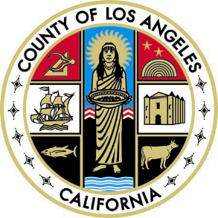



The Asian Pacific Community Fund (APCF) is a network of 29 community organizations focused on serving the vast and critical needs of the Asian, Pacific Islander, and other ethnic communities in the Greater Los Angeles area. APCF Affiliate Agencies provide culturally sensitive and linguistically appropriate programs and services in 27 Asian languages plus English and Spanish to over 250,000 people each year throughout Los Angeles County.
APCF is a community-based, nonprofit fund that was created to fulfill a need for a unified effort to educate and encourage donors to direct their charitable giving to benefit community organizations serving the rapidly growing population of Asian Pacific Islanders in Los Angeles.
Since its founding, APCF has raised and distributed over $1.7 million in unrestricted grants to its Affiliates. These grants enable APCF agencies to both launch new initiatives and strengthen current programs and services for diverse Asian Pacific Islander clients, including: disadvantaged children, youth, disabled, seniors, immigrants, refugees, battered women, and low income families.
As the only Asian and Pacific Islander community-based fund in Southern California, the work of APCF is more important now than ever. APCF is and continues to be -- a vital link -- between donors and Asian Pacific Islanders in need by building a community of giving, one donor at a time.

To learn more, visit www.apcf.org or call (213) 624-6400.
Debra Fong, Executive Director

